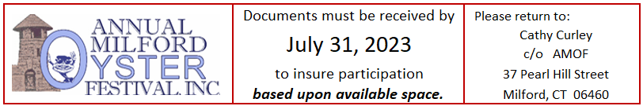
Main Street USA – 2023 Contract – Participant
49th Annual Milford Oyster Festival – Saturday, August 19, 2023 10 a.m. – 6 p.m.
On the Historic Milford Green
Between the Annual Milford Oyster Festival, Inc. (AMOF) and
COMPANY/BUSINESS NAME:
CONTACT:
PHONE:
EMAIL:
ADDRESS:
DESCRIPTION of PRODUCTS / SERVICES:
CATEGORY & PRICING (see below):
PAST PARTICIPANT? Yes: _______ No: _______ If yes, please note most recent year: ______________

WELCOME and INSTRUCTIONS
- Choose your category and indicate above. (Note: prices after July 14 will be $25 higher.):
Category #1: 10’ x 10’ space, tent, one table and two chairs
Milford Business: $375 All Others: $400
A $100 deposit is required with your payment. It will be refunded as long as your firm’s representative stays until the end of the Milford Oyster Festival.
Do you need a tablecloth for your table? Yes: No: ________
Do you need access to an electrical outlet? Yes: No: ________ ($20 extra)
Category #2: 10’ x 20’ space, tent, two tables and four chairs
Milford Business: $625 All Others: $650
A $100 deposit is required with your payment. It will be refunded as long as your firm’s representative stays until the end of the Milford Oyster Festival.
Do you need a tablecloth for your table? Yes: No: ________
Do you need access to an electrical outlet? Yes: No: ________ ($20 extra)
All tents must be supplied by the AMOF Committee. Table dimensions are 8’ x 30”.
Space will not be guaranteed until payment is received.
- Please read, sign and return this Participation Contract to the Main Street USA Committee Chairperson, Cathy Curley (address at top), along with appropriate fees and insurance policy declaration as specified here-in.
- Please indicate if payment will be made by PayPal or check.
PayPal: ________ (An invoice will be emailed to you.) Check(s): ________ (Please send in.)
- When submitting your contract, please return the completed Certificate of Insurance as well.
Section I – RULES & REGULATIONS

Said business agrees to abide by all Rules and Regulations that may be promulgated by the Annual Milford Oyster Festival, Inc. (“AMOF”) as set forth herein:

Weather: The Annual Milford Oyster Festival will be held rain or shine. It will end early only if an announcement is made. Otherwise, Main Street USA vendors are expected to remain until the end of the Oyster Festival.

Cancellation: In the event an applicant has been accepted as an exhibitor in the Festival but then wishes to cancel, the following will apply:
- Cancellations must be in writing.
- Cancellations made more than thirty days prior to the Festival will allow the exhibitor to receive back the space fee less a 25% (twenty five percent) processing fee.
- Cancellations made thirty days or less prior to the Festival will result in the forfeiture of the exhibitor’s space fee.
In the event it becomes necessary to cancel the Annual Milford Oyster Festival, all space fees will be refunded.

Setup/Parking: The closing of streets will start at 8:30 a.m. Streets will be fully closed by 9 a.m. No exceptions. Your Business must arrive before the streets close and be set up ONE HOUR before opening time of the Festival. Representatives of each Business must park in designated parking areas.

Trademark/Servicemark Rights: The Festival name (sic, “Milford Oyster Festival” or “Annual Milford Oyster Festival”) and oyster character are protected by registered trademark and servicemark property rights of AMOF. Before using this name or logo on goods for sale or otherwise, the user is cautioned to seek approval for appropriateness by AMOF and obtain AMOF’s written consent to use them by signing a license agreement. Unauthorized use of this Festival name and logo may subject violator to being shut down, expelled from the Festival grounds, arrest and criminal prosecution and liability for damages. Users are also cautioned to add at least a three-week lead-time to your order time to allow AMOF time to review, approve and have a license agreement signed and returned to you.

Space Allocation: Each Business will receive a designated area in which to set up. This space is to be used solely by the Business whose name appears on this Contract document and the Business agrees to stay within the boundaries of its particular location. A request for a specific area will not be guaranteed. Prior participation in the Festival does not give any preference to a certain space location. Each space is approximately 10 ft x 10 ft depending on the Pricing Option selected.

Use: The Business understands that the use of its space is solely for the purpose of gathering sales leads/advertising only. Sale of any products and/or services is strictly prohibited. The Business cannot sublet nor share its display area unless otherwise authorized by AMOF. No merchandise may be sold nor given away if it will be in competition with what a Non-Profit vendor will sell; i.e., bottled water, food samples. (If in doubt, please check with the Main Street USA Chairperson.)

Representative: On the day of the Festival, the Business must have a representative of the Business present at its display area for the entire time the Business is set up. Failure to have a representative present during the Festival will subject the Business to expulsion from the Festival and forfeit of their deposit.

Pack it in / Pack it out: Please do not dispose of any trash in the City trash barrels located throughout the Green. Contractor-size trash bags will be provided to each exhibitor to bag and remove the trash generated from your exhibitor area. Trash bags should be placed by the curb.

Breakdown Time: The Festival ends at 6 pm. You are not allowed to break down your designated space or move any of your parked vehicles prior to 6 pm. A deposit of $100 is required and will be returned as long as you meet the 6 p.m. guideline. This deposit should be paid on a separate check and will be returned within four weeks after the Festival if you stay until 6 pm. If you leave early, then the $100 deposit will be forfeited.
Right to Remove: AMOF reserves the right to remove any Business participating for inappropriate behavior or violation of its Rules & Regulations.

Section II – LIABILITY INDEMNIFICATION AND INSURANCE

Liability Indemnification: The Milford Chamber of Commerce, AMOF, City of Milford or any member or representative of any of the aforementioned organizations or entities will not be held responsible for any injury, loss or damage that may occur to the participating organization or the participating organization’s representatives or property from any cause whatsoever. The Business, on signing this Contract, expressly releases the Milford Chamber of Commerce, AMOF, City of Milford and any of their Officers and Participants from any injury, losses or damages related directly or indirectly, in whole or in part to the Business’ presence or activities at the Milford Oyster Festival.

Liability Insurance: Any Business that participates in the Festival at the Main Street USA venue must briefly describe the nature of its activities. Proof of Liability Insurance is required with the Annual Milford Oyster Festival, Inc. named as an additional insured party. A copy of your Certificate of Liability Insurance must be obtained from your insurance company and returned with this Contract. (Please follow the highlighted format outlined in the sample Certificate of Insurance.)

On behalf of the said Business, my signature below indicates that I have read, understand and agree to the above terms, conditions, rules and regulations of this Contract to participate in Main Street USA at the 2023 Milford Oyster Festival. I also understand that no space is guaranteed unless a signed contract, payment and proof of liability insurance have been received by the Annual Milford Oyster Festival and I have received confirmation of my space from the Festival Committee. If payment has not been received by July 14, 2023 for reserved space, that space will be made available to individuals/organizations that have been wait-listed.

Business Name: _______________________________________________________________________

Printed Name: ________________________________________________________________________

Printed Title: _________________________________________________________________________

Signature: ____________________________________________________ Date: _________________

Please send the contract with payments and proof of liability insurance by July 14, 2023 to:
Cathy Curley, AMOF Main Street USA Chairperson, 37 Pearl Hill Street, Milford, CT 06460.

Questions, please call Cathy: 203-878-7286 (home) or 203-305-7813 (cell) or email her at CTAMOF@aol.com

Payment may be made by check or PayPal. (Directions for PayPal may be found on the attached checklist.)

*** Both checks should be made payable to: ANNUAL MILFORD OYSTER FESTIVAL, INC.
  - First check for the Category fee.
    - Please add $20 if an electrical out is needed.
  - Second check for the refundable deposit ($100) for Full-Day Participation as noted above in the Section I - Breakdown Time paragraph.
***Space will not be guaranteed until payment is received.
*** All tents must be supplied only by the AMOF Committee due to regulations imposed by the City of Milford and the AMOF guidelines.

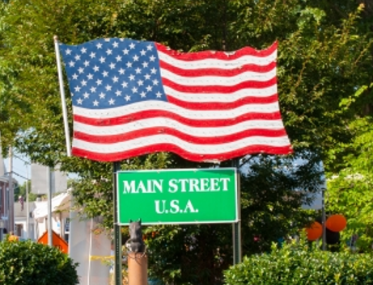

If you would like information on how to become a sponsor of the Festival which would include additional brand and marketing exposure as well as the potential ability to use your own branded tent, please contact Jay Pinto at jaypinto@aol.com

